SOCIO-LEGAL STUDIES ASSOCIATION
MINUTES OF THE EXECUTIVE COMMITTEE
13 MAY 2004 AT UCL

NB: EXECUTIVE COMMITTEE MEETINGS DATES: 23 September 2004 (This meeting to be held in BELFAST), 20 January 2005, 12 May 2005 at UCL

1. Attendance and apologies for absence: Present—Anne-Maree Farerell, Marie Selwood, Bettina Lange, Morag McDermont, Helen Carr, Lois Bibbings, Dave Cowan, Mary Seneviratne, Julian Webb, Anthony Bradney, Mike Meehan, Daniel Monk, Bronwen Morgan, Lisa Glennon, Paddy Hillyard, Alison Dunn, John Flood.
Apologies for Absence—Richard Collier, Grace James, Richard Moorhead, Anne Barlow, Nick Jackson, Sally Wheeler, Tom Mullen, Helen Stalford/Warren Barr, Lisa Webley.

2. Minutes of last meeting: Have been posted on the SLSA website at http://www.kent.ac.uk/slsa/contacts.htm.

3. Matters arising from minutes: None.

4. & 5. Chair’s & Vice-Chair’s reports: At the next AGM the SLSA will need a new chair, vice-chair, secretary, treasurer, recruitment secretary, and membership secretary as the present executive members will be retiring as per the constitutional requirements.

Furthermore, we need a new vice-chair for the next 11 months until the next AGM.

Sally Wheeler, the current chair, is still unwell, so the vice-chair made the report.

- The website is to be kept going and now contains more useful information than before
- We will be arranging a meeting with the ESRC because the ESRC has hired a new socio-legal officer, viz., Tracy Davies.
- Dave Cowan coordinated with Tom Mullen at Glasgow over the conference plenary (Phil Scraton, Hazel Genn, Tony Bradney), which was well-received.
- Re-worded the book and article prize conditions, which resulted in a very strong submission this year.
- Will write to head of Stirling law school on the death of Doug Vick. We will need an obituary for the newsletter.
- The question of what to do with the funds the SLSA has accumulated was raised. The suggestions put forward were: the individual amounts for the small grant scheme be raised to £1,500 and the overall budget increase to £8000.
- LSA Summer School: we will support SLSA members at the summer school up to a maximum of £6000. The detailed breakdown of eligibility and per person cost is to be approved by a circulated email as agreed at the executive meeting.
- International Law and Society Association proposal: We will wait for further information.

6. Treasurer’s report: report attached below. The treasurer stated she would be content with a balance of £20,000 in the deposit account. Paddy Hillyard said he would submit a proposal on the proposed methods book.

7. Membership secretary’s report: A new database has been compiled and the SLSA has some new members join since the AGM.

8. Recruitment secretary’s report: No change since AGM report.

9. Newsletter editor’s report: report attached below.

10. Directory editor’s report: report attached below. Points to be noted are that the publication date has changed to the year’s end. The remaining copies of this year’s directory will be sent to Westminster. The Legal Action Group has said it wishes to take a full-page spread in the newsletter.

11. Webmaster’s report: report attached below. The SLSA website is now up to date. And the SLSA has its own copy of Dreamweaver.

It was asked that the links on the website to the research links be clarified to ease navigation.

12. Scottish branch of the SLSA: Tom Mullen has become the Scottish representative on the retirement of Anne Griffiths from the executive.

13. Nuffield Enquiry into Empirical Research in Law: After much discussion, it was agreed that the SLSA ought to submit a response and a sub-committee of John Flood, Bronwen Morgan, Tony Bradney, and Mike Meehan would prepare a response to the Nuffield questions.

14. RAE 2008: matters for discussion attached below. After much discussion on which panel socio-legal studies should be part of and who should be on the panel, the executive agreed that socio-legal studies should stay with law in Group I and argue for autonomy on pragmatic grounds.

We should propose panel members including some from the previous RAE 2001. The names proposed are: Sally Wheeler, Stephen Weatherill, Roger Cotterell, Davina Cooper, Andy Boon, Christine Chinkin, Andrew Saunders.

A question about the status of pedagogical research within disciplines was raised. Law now has 7 journals in this area. The executive thought this area should be dealt with on a panel basis, ie, legal education research should be within law.

A further question was raised about the status of research reports as submissions to the RAE. This will be the topic of a later consultation.

15. ESRC ‘Future Directions for Social Science’: The SLSA ought to respond to the ESRC enquiry. The questions have been placed on the SLSA website bulletin board for members to comment on.

A response sub-committee was formed of John Flood, Tony Bradney, Mary Seneviratne, and Anne-Maree Farrell.

16. Ethical code and research ethics: The standing committee is now Helen Carr, John Flood, Julian Webb, and Helen Stalford (following maternity leave).

The ethics one-day conference is an important conference for us. The total expenditure is noted at £1,300. The executive recorded its grateful thanks to Anne Barlow for organising this conference.

17. Annual conferences:
- Glasgow: As yet we have no final report on the Glasgow conference as the final costings are proving difficult.
It was noted that mobility problems arose and we had stressed that these had to be taken into account, but this fell outside Tom Mullen’s authority.
In future we must include someone to handle access, catering, etc.
It was concluded that conference day visitors should pay somewhat more than a third of the full conference fee in order to encourage them to attend the entire conference.
- Liverpool: no report. It was mentioned that we should provide space for postgraduate poster displays.
- 2006-07: There was discussion of possible venues.

18. Postgraduate conference: Lancaster will host the 2005 postgraduate conference. The executive expressed its gratitude to Bela Chatterjee for arranging this.

19. One-day conferences: The ‘Risks in Society’ proposal was broadly welcomed. It was noted that it was aimed at postgraduates. The discussion concluded with the thoughts that the conference could be opened up and be more ambitious in its scope. Morag McDermont will follow up for the executive with Maryam Alami. It was also agreed that she should approached to become the postgraduate representative on the executive.
The newer members of the executive, as well as the current, were asked to bear in mind the need for one-day conferences.

20. Methodology workshops: Bettina Lange and Tony Bradney will be working together on the workshops.

21. Article and book prizes: We had excellent submissions and two extra judges had to be co-opted because there were 26 articles and 20 books submitted.
The rules will be amended to exclude submissions from serving executive members.

22. Any other business: Dates for the next set of meetings: 23 September 2004 (to be held in Belfast), 20 January 2005, 12 May 2005.
The small grants panel will be chaired by John Flood and include Mary Seneviratne and Paddy Hillyard.
(See item 6)

SLSA INCOME AND EXPENDITURE

1 MARCH 2004 – 10 MAY 2004

INCOME

Bursaries (Cardiff Law School) £1000

Publisher’s inserts (newsletter) £600

Membership (cheques) £135

TOTAL £1735

EXPENDITURE

Newsletter £1749
Commission for inserts £60

Bursaries £2510

Executive expenses £852.29

Book and article prizes £600

Website £935

TOTAL £6706.29

Balance in current account = £5138.86

Balance in deposit account - £40,545.03

(See item 9)
Newsletter Editor’s Report to SLSA Executive Committee
Marie Selwood
13 May 2004

General
Printing and distribution of newsletter
The newsletter was again distributed a few days late despite the fact that we pulled the publication date forward to be certain of delivery in time for the conference. I was also disappointed again with the paper and the ink colour and have brought these problems up with Cavendish. Cavendish also omitted their advertisement on the back.

I think the best policy is for me to continue to stress to Cavendish the importance of aiming for a high quality of printing in the hope that they will eventually get it right. As the choice of printer rests entirely with Cavendish, then there is little else that I can do. I have already begun raising the point with them for the next issue.

Number 42 (Spring 2004)
Content
Again, I was pleased with the content and received so much material that I had great difficulty fitting it all in without it looking too cramped.
- total editorial pages 13

Printing and distribution
Delivered four days late again. See above. Problems with paper and ink colour. Cavendish advertisement omitted.

Mailing
- print run 3500
1200 for mailing list
800 for distribution with JLS
500 for conference
1000 for Law and Society Annual Meeting (sent to Chicago in April).

Inserts
- 1200 Vathek publishing
Number 43 (summer 2004)

Deadlines
Copy from contributors –14 June
Files to Cavendish – 12 July
Publication – 2 August

Content
This issue will contain a follow-up from the plenary by Phil Scraton. Richard Collier is also making a contribution to this debate and Martin Partington is reporting on the Nuffield enquiry meetings. Details of the small grants scheme will also be included, and the book and article prizes information. Plus all the regular sections (people, events, publications, courses, research). Comments and ideas welcome from exec members.

Other points
- print run – 2000
800 for JLS
1200 for membership list
- pages 13 and 14 Liverpool conference
- total editorial pages –13

Inserts so far
- Journal of Social Welfare and Family Law
- SLSA Directory form

(See item 10)
Directory Editor’s Report to SLSA Executive Committee
Marie Selwood
13 May 2004

Directory 2004
Covered in report to AGM 2004

Directory 2005
Change of publication date
As discussed at the January Executive Committee meeting, I have rearranged the publication date of the Directory. It will now be delivered to Westminster by mid-December for them to distribute before Christmas if convenient or by the end of January at the latest.

Deadlines
- Deadline for entries 15 October 2004
- Files to Butterworths 31 October 2003
- Delivery date 15 December 2004.

I will include the Directory entry form in the summer issue of the newsletter and start emailing members about the changed publication date in the next few weeks. The new details are already on the website.

As usual I will be as flexible as I can about late entries.

Print run and distribution

There were rather a lot of spare copies at the conference this year. We need to make a decision on the print run (currently 1000) and decide whether to keep to this or reduce it. If we don’t reduce it we need to decide what to do with the extra copies.

(See item 11)
Website Editor’s Report to SLSA Executive Committee
Marie Selwood
13 May 2004

Relaunch

An extensive update has been carried out on the site as discussed at the January Executive Committee meeting. The new site went live on the first day of the annual conference.

It now contains a lot more information and is under constant review. We did experience some problems with software and setting up a system which would work for all involved. As far as my role is concerned, Nick Jackson has purchased a copy of the Dreamweaver software on behalf of the SLSA which I now have up and running. This means that I can make editorial changes to files and email them to Nick who can then upload them onto the site. This gets rid of a lot of duplication of work for the two of us.

Work on the site will now be focused on keeping it up to date and suggesting changes/modifications for the future. I propose to do a few hours a month on this. Suggestions and contributions from Executive Committee members would be very welcome.

Research areas

This section is the part that still needs some work. We eventually got quite a lot of input here (thanks to all those who contributed), but there are still some subjects not covered (see below). If anyone would like to volunteer for these, I’d be very grateful.

Access to justice
Civil liberties and human rights
Environmental law
Financial services regulation
Health care law
Law and economics
Law and literature
Law and social theory
Legal education/legal skills
Legal geography
Legal history
Property, equity and trusts
Regulation
Religion and law
Research methods, methodology

(See item 14)
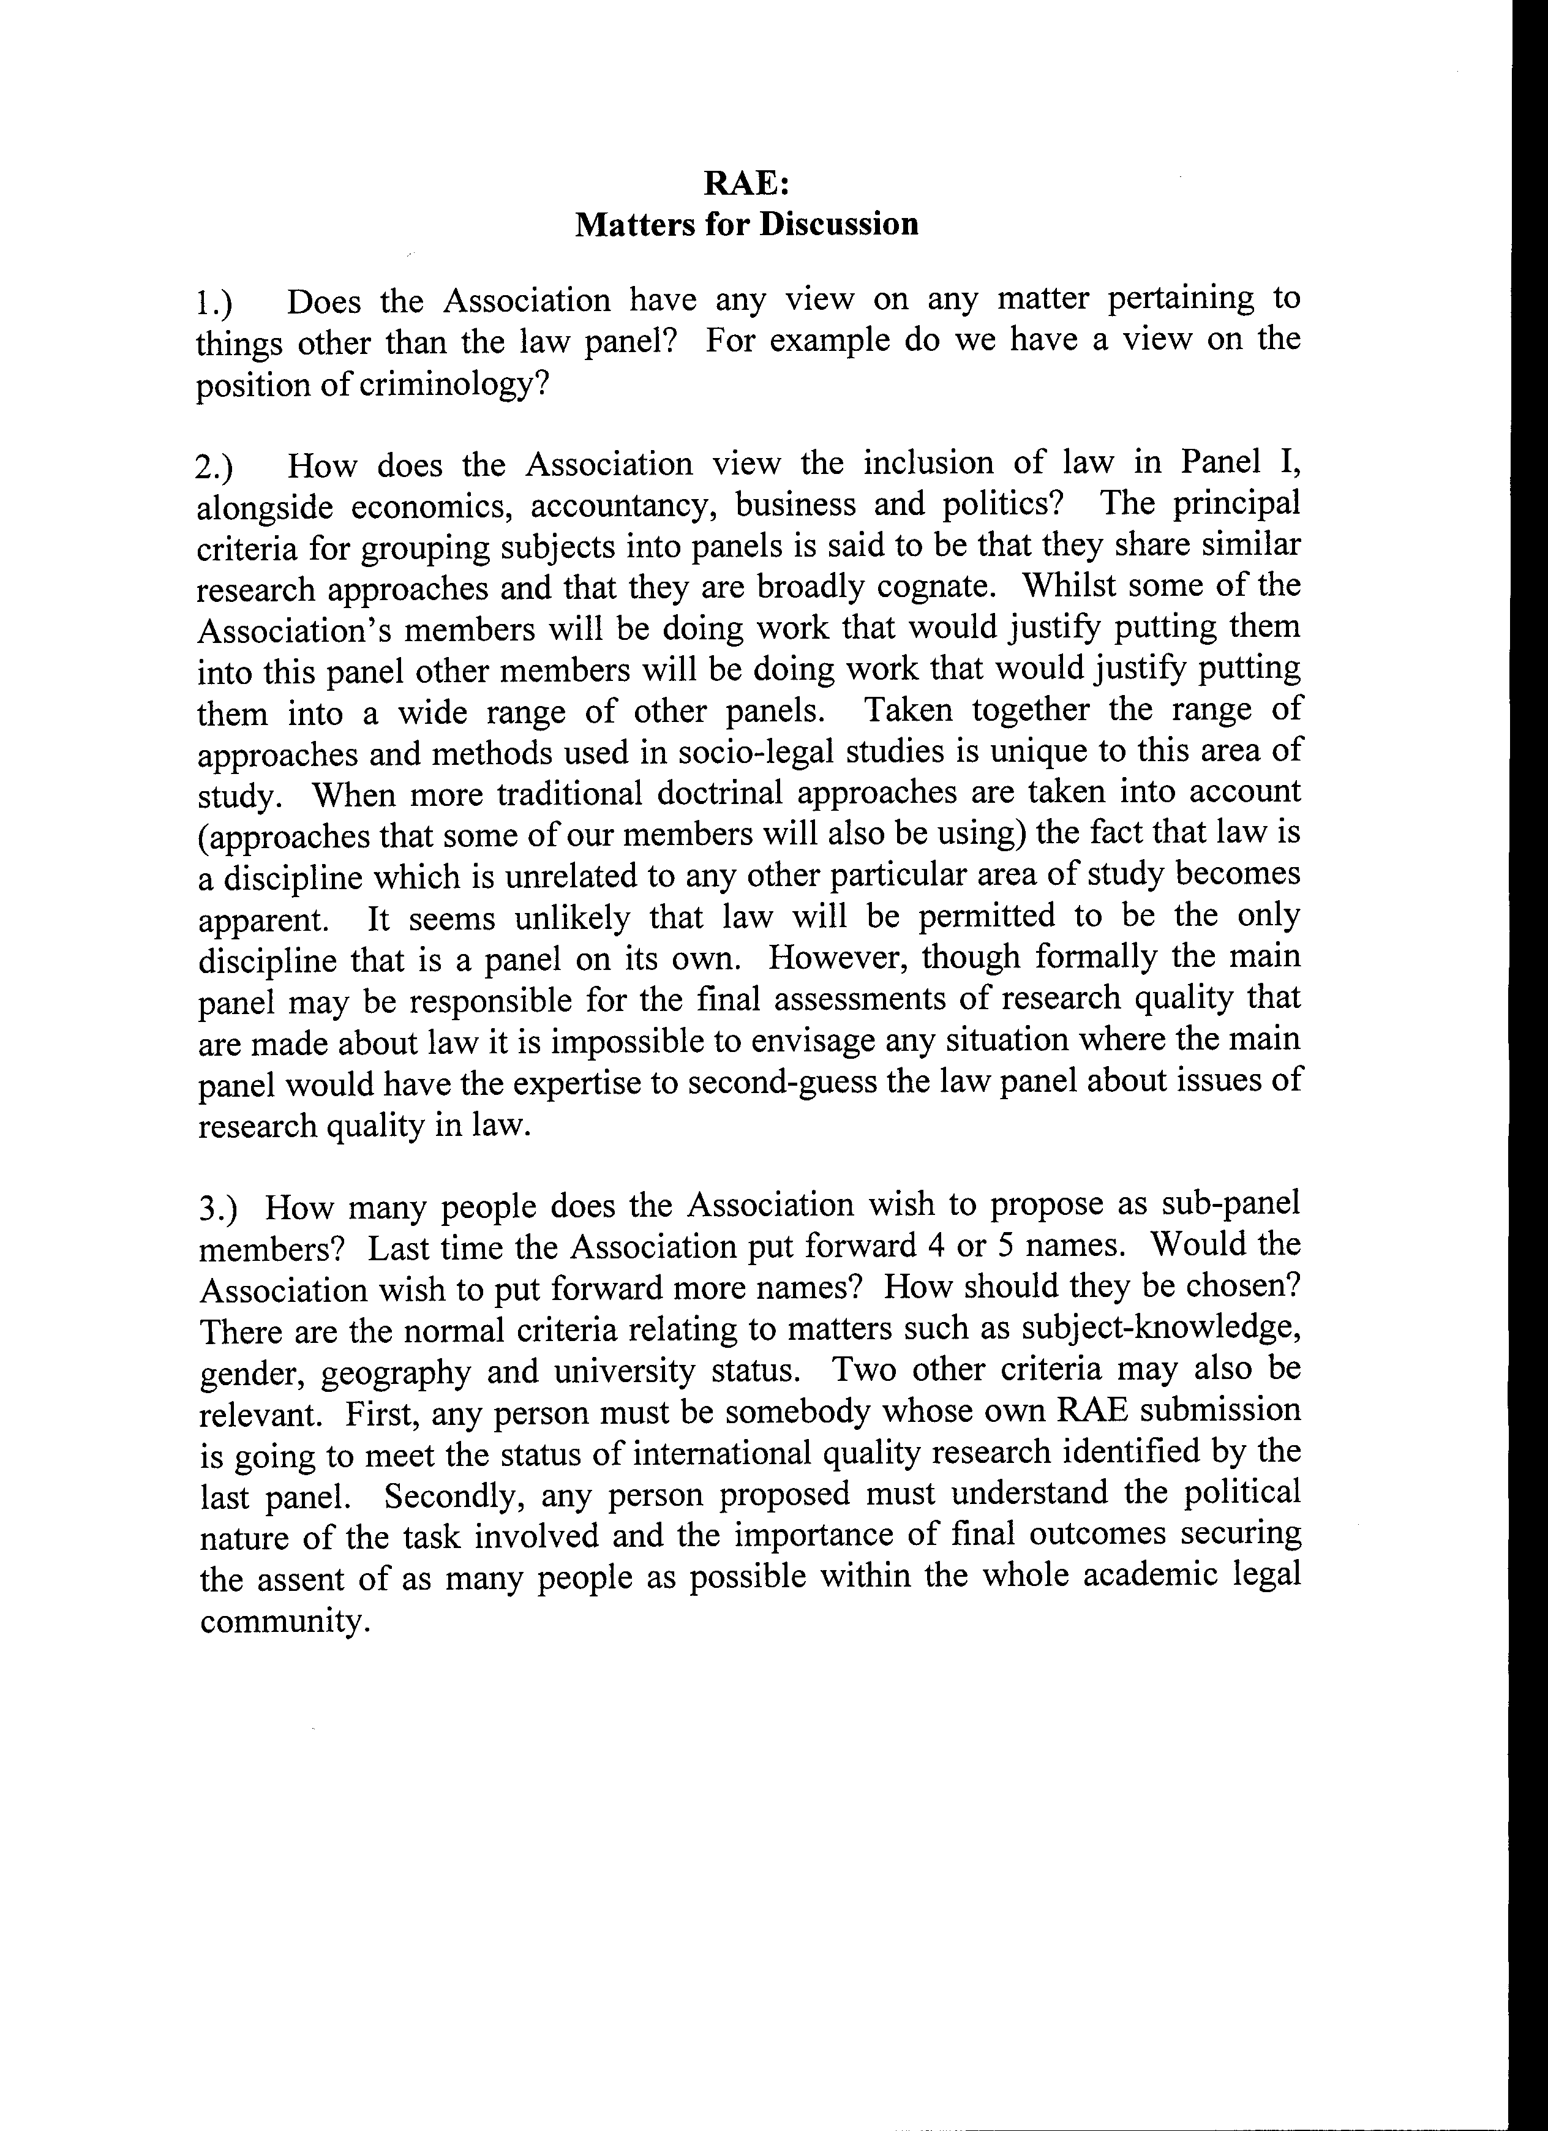

A further £1000 is due from Blackwells. Invoice sent mid March.
Payments are due 1 July. Most standing orders are paid then. Reminder letters for cheque payments will be sent out next week.
Only £510 is from SLSA funds. See fn 1.
This includes payments for lunches for four executive committee meetings, invoices for which have recently been received, totalling £467.40, and expenses of £196.60 for Phil Scraton’s attendance at the plenary of the Glasgow conference.
£500 is due from Harts for this. An invoice was sent on 26 April.
This was agreed at the last meeting, and covers M.Selwood’s work in helping to update the website.

