Socio-Legal Studies Association

Annual General Meeting (Glasgow 2004)

Minutes 6 April 2004

1. Attendance and apologies for absence. Attendance: Dave Cowan, John Flood, Morag McDermont, Anthony Bradney, Nick Jackson, Helen Carr, Fiona Cownie, Mary Seneviratne, Fiona Raitt, Bettina Lange, Bronwen Morgan, Lisa Webley, Richard Moorhead, Mike Meehan, Eliza Pop, Robert Dingwall, Reza Banakar, Paddy Hillyard, Ed Cape, Rebecca Probert, Grace James, Lisa Glennon, Anne Barlow, Ken Mackinnon, Julian Webb, Mwaka Chulu, Linda Mulcahy, Tom Mullen, Lois Bibbings, Richard Collier, John White, Mavis Maclean, Jim Goddard.
Apologies: Sally Wheeler, for whom we send our best wishes for a rapid recovery; Marie Selwood.

2. Minutes of the last AGM are available on the SLSA website (http://www.kent.ac.uk/slsa/).

3. Matters arising from the minutes: none.

4. Executive nominations: The new nominees are Daniel Monk (Birkbeck), Richard Moorhead (Cardiff), Bronwen Morgan (Oxford), Anne-Maree Farrell (Lancaster), Julian Webb (Westminster), Grace James (Reading), and Bettina Lange (Keele), Helen Stalford/Warren Barr (Liverpool). All are duly nominated.
Those leaving the executive committee are Andy Boon, Hazel Genn, Anne Griffiths (Scottish representative), Phil Thomas. The SLSA is very grateful for all the hard work they have put in as executive members.

5/6. Chair’s report and vice-chair’s report: Because of the illness of the chair, the chair’s report is combined with that of the vice-chair. The report is attached (see below). The vice-chair welcomed the fact that the small grant applications are getting stronger each year and that the newsletter is stronger and more hardhitting than ever.
Dave Cowan requested that ideas for one-day conferences be submitted to him.
The vice-chair also gave a big vote of thanks to the Journal of Law and Society for providing postgraduate bursaries and supporting the plenary session.
Comment from audience: has the SLSA picked up on the ESRC exercise on developing a framework for social science research ethics? The vice-chair noted that we were monitoring the situation. Further details of the exercise can be found at http://www.york.ac.uk/res/ref/index.htm.
The vice-chair pointed out that his term of office officially came to an end with the 2004 AGM, but in view of the chair’s illness and after discussing the issue with the secretary and treasurer he would continue in office until the chair has returned to her duties.

7. Treasurer’s report: The report is attached (see below). The SLSA would like to express its appreciation to Prof Michael Gunn for auditing the accounts.
Comment from audience: why don’t we overspend on small grants because it is a key service to members? The vice-chair answered that we may increase the bar on individual grants from £1000 to £2000. Dave Cowan also commented that we are watching carefully the trial free membership programme for postgraduates.

8. Membership secretary’s report: The report is attached (see below).

9. Recruitment secretary’s report: There are now two recruitment flyers, a general flyer and a new postgraduate student version. The latter promotes a free membership offer to encourage postgraduates to join the Association. We are promoting this as a 'newsletter anniversary' offer. Copies of the student and general flyer are being circulated at the conference.

In addition to the usual modes of distribution, Marie is arranging for copies of flyers to go out with the new JUSTICE journal.

Can I encourage members to contact me at Lois.S.Bibbings@bristol.ac.uk if they are organising conferences, or can suggest other means of distributing flyers.

10. Newsletter editor’s report: The report is attached (see below).

11. Directory editor’s report: The report is attached (see below). The SLSA is grateful to the University of Westminster School of Law for handling the distribution and posting of the Directory, and is also grateful to Butterworths for publishing the Directory.

12. Webmaster’s report: The SLSA website has been relaunched, (http://www.kent.ac.uk/slsa/) with a new bulletin board service which was to be developed initially to help Lisa Webley with her announcements of events . The website is still in its preliminary phase so the webmaster welcomes comments on improvements (Nick Jackson slsa-admin@kent.ac.uk).
Dave Cowan thanked the members who had compiled research lists for the links page (http://www.kent.ac.uk/slsa/research/areas.htm), and also thanked Nick Jackson (Webmaster) and Kent Law School for hosting and upgrading the SLSA website.

13. Any other business: The SLSA would like to record its gratitude to Tom Mullen, Liz Auchincloss and their colleagues for organizing a splendid conference in Glasgow.
The SLSA recorded its thanks to its officers for their work during the past year: Sally Wheeler, Dave Cowan, John Flood, Mary Seneviratne, Lois Bibbings, Lisa Webley, Marie Selwood, Nick Jackson.
Finally, the SLSA expressed its thanks to Dave Cowan for both vice-chairing and chairing the SLSA executive during Sally’s illness.

Reports attached below in order of agenda
Socio-Legal Studies Association
Annual General Meeting
Glasgow
6April 2004

Chair and Vice-Chair’s Report

As ever this year has been a busy one for the SLSA. The following is a summary of the activities of the year.

Research issues
As an Association we have, through the Newsletter and Annual Conference, continued the debate first highlighted by Michael Adler around the issue of research capacity. The Chair has been involved with the day-to-day work of the Nuffield Inquiry into empirical research, and the issues raised have been discussed at length at meetings of the Executive. Under the leadership of Tony Bradney, we are exploring the possibilities for putting on our own research training/seminars. The various consultations exercises around RAE2008 are beginning to occupy some considerable time, and we have also responded to a variety of consultation exercises, such as the National Centre for Research Methods at Southampton. As reported at the last AGM, the decision was taken to recommence running a postgraduate-specific conference. We were extremely grateful to Mike Meehan and Liverpool John Moores University who ran an extremely successful conference. Additionally, we were grateful to the many senior scholars who gave up their time to present and discuss issues at that conference.

One-day conferences
This year has been a somewhat fallow year for one-day conferences. But those which have taken place, such as the successful conference exploring the social and legal implications of the genomic revolution, have sought to develop cutting edge studies and spaces. As ever we are keen to support members of the association who are prepared to organize one-day conferences and would encourage them to do so. This year, there will be a number of one day conferences – the Association is keen to promote awareness and discussion of its Ethical Code. Anne Barlow will be organizing a one day conference on research ethics, particularly considering data protection. Michael Naughton will also be organizing a conference to discuss the feasibility of a UK Innocence Project.

Small grants
This year, we were again delighted with the quality of applications for small research grants and the Sub-Committee was able to make seven awards to members at different stages in their careers. Once again, the amount set aside for these grants was exceeded slightly by the sub-committee on Chair’s action. We remain determined to continue with this high profile scheme, particularly as a result of the high quality in applications. However, we would, of course, welcome having a greater number of applications.

Prizes
In recent years, we have been concerned that the Hart/SLSA prize for the best socio-legal book has not been awarded. The Executive Committee decided that it would be best to split the prize – one for the best book and one for the best book emerging from a research degree. This year, there was an exceptionally strong field for both of these prizes as well as for the articles prize and we were able to make awards for all of our prizes. Names of the prize winners appear in the conference handbook and we extend our congratulations to them all.

Conference venue, 2005
The conference venue for 2005 will be Liverpool University. Our link persons there are Helen Stalford and Warren Barr. We are very grateful to them for taking on this mammoth task. We are at the moment considering proposals to host the 2006 conference. Expressions of interest should be directed to either Sally Wheeler or Dave Cowan.

Website and Newsletter

We feel that the Newsletter has gone from strength to strength under the editorship of Marie Selwood. Articles have been hard-hitting and the Newsletter has taken a prominent role as a mouthpiece for concern over issues about research capacity, higher education, and critical criminology. It also provides a space in which the research of our members can be given a higher profile.

The website has recently been an issue of high profile amongst members of the Executive. Since Martha-Marie Kleinhans left the Executive, there has been a marked reduction in usability of the website. However, as of this morning, it has now been relaunched with an advanced bulletin board and other technical advantages. We are grateful to the hard work of Marie Selwood in co-ordinating this process, Nick Jackson and colleagues at Kent for giving of their time freely in updating the site, and those academics who have helpfully provided subject-specific links. Ongoing updating of the site should now take place regularly, but we hope that you will also assist by letting us know of any problems or links you would like to make. The relaunched website should also streamline the process of e-mail notifications.

Thank you
On behalf of the Association, I would like to thank the board of the Journal of Law & Society for their very generous contribution to Association funds and, additionally, their financial bankrolling of tomorrow’s plenary lecture.

Finally, my thanks go to all those members of the executive who have made contributions to the smooth running of the Association.

Sally Wheeler (Chair) & Dave Cowan (Vice-Chair)

SOCIO-LEGAL STUDIES ASSOCIATION
TREASURER’S REPORT 2003-2004

1. This is my fifth treasurer’s report to the annual general meeting. As last year, the accounts have been audited by Professor Michael Gunn, for which I would like to record my appreciation.

2. The accounts cover the period 1 March 2003 to 29 February 2004.

3. As can be seen from the accounts, the Association continues to maintain a healthy financial position. The balance of income over expenditure this year was over £11,000, due mainly to a very successful conference in 2003, and also an increase in membership subscriptions compared to last year. The large balance in the account has made it possible to transfer £20,000 from the current account into an interest bearing deposit account in order to provide more reserves. There is a healthy balance with which to start the new financial year in the current account, plus reserves of over £40,000 in the deposit account.

4. Conferences. As in previous years, our major source of income is the annual conference. In 2003, the conference raised over £19,000. The SLSA needs to raise £10,000 from its annual conference in order to fund its activities. The success of the last two conferences has ensured that there are sufficient funds to do so. The SLSA underwrites one-day conferences, and this year it was decided to underwrite a dedicated postgraduate conference at Liverpool in January. The cost to the SLSA of this conference was just less than £1,200, which was well within the £3,000 budget allocated.

5. Membership. The SLSA budget is prepared on the basis that around £10,000 will be raised through membership fees. This year, for the first time, not only was this target reached, but it was exceeded by almost £1,400. As indicated in the membership report, this is due to an increase in membership numbers and also to a drive by the Membership Secretary to ensure that membership payments are current and accurate. Despite this, there are still a number of members who have not increased their standing orders from £25, and even a few who are still paying £15. This represents a significant loss of funds for the Association. Expenses in relation to membership have been incurred this year as a result of a decision to try to increase the numbers of members (hence the cost of the poster), and to ensure the accuracy of the membership database.

6. Bank interest. This shows a decrease on last years total, due to the fact that interest ceased to be paid on the current account in October 2003. The decision to transfer such a large amount of funds to the deposit account was a result of this.

7. Newsletter. The new system for producing the SLSA Newsletter has now been in operation for over a year. The cost of production (taking into account the income from publishers’ inserts) was £7,585. This represents a considerable saving on previous years, and moreover, without any reduction in the quality of the Newsletter.

8. UK Centre for Legal Education. The income and expenditure for this relates to a research project conducted over the last two years, as a collaborative proposal between the SLSA, Women in Legal Education Network, and Women Law Professors Network. The SLSA handled the account for this, and it was not possible to finalise the account last year, as the project had not then been completed. Taken over the last two years, the total income was £4,900, and the total expenditure was £3,963.52, making a net gain to the SLSA of £936.48.

9. Postgraduate bursaries. Unlike previous years, the bursaries for the 2003 conference were entirely funded by the Journal of Law and Society and Blackwells Publishers. In previous years, bursaries funding has come out of SLSA funds. The funding this year enabled all applicants for bursaries to have their accommodation and conference fees met, and contributions towards traveling expenses for those requesting this. This very generous contribution enabled more students to be assisted than has been possible in the past.

10. Small grants scheme. As last year, there was a slight overspend on the budget set for the small grants scheme. This was accepted on the basis of the quality of the applications.

11. As last year, I have presented in diagrammatic form our main income and expenditure. As noted above, income comes from conferences and membership fees, with a little from royalties and bank interest. Ideally, the Association would receive £20,000 a year, with £10,000 each coming from the annual conference and membership. In 2003, we were well over the target for conference income, and, for the first time, over the target for membership fees. As for the expenditure, the newsletter is taking up about one quarter of the Association’s income, whereas in the past it has sometimes accounted for well over half. The costs of the directory and executive expenses have all come within the suggested budgets for the year.

Mary Seneviratne
Treasurer
March 2004
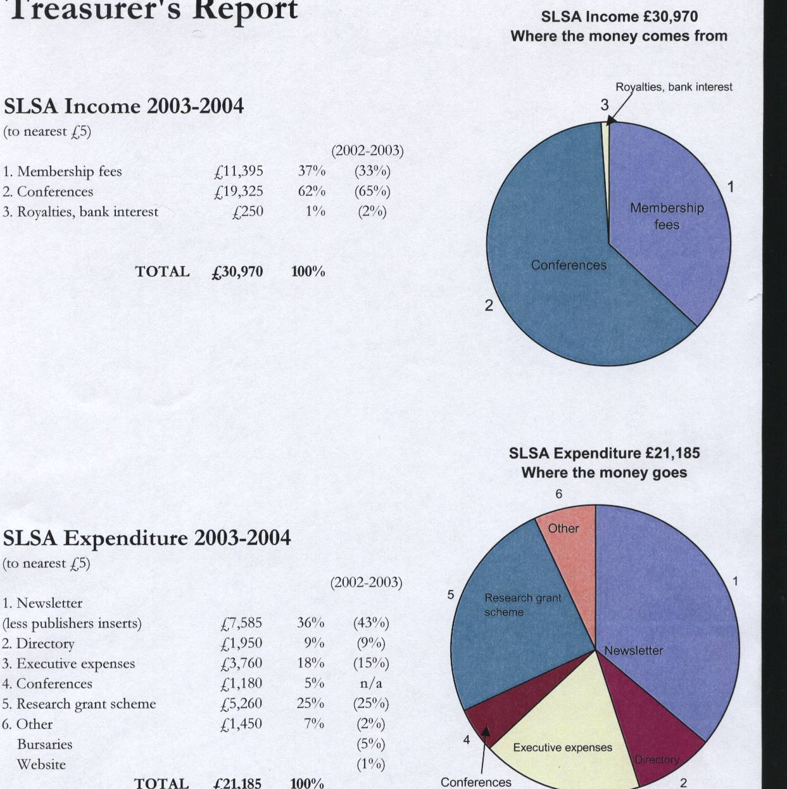

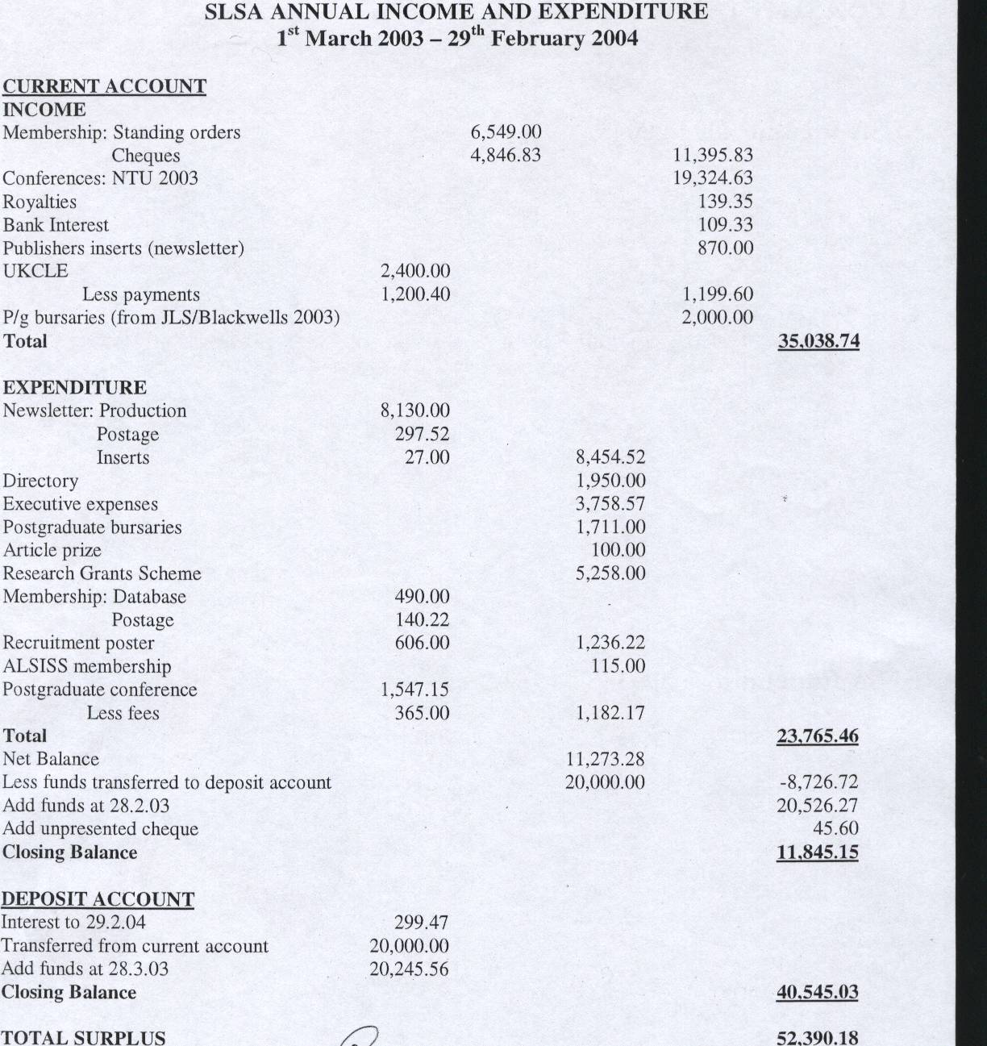

Audited and found correct (signed) M Gunn
Date 1/04/04

SOCIO-LEGAL STUDIES ASSOCIATION
MEMBERSHIP SECRETARY’S REPORT 2003-2004

1. I took over as Membership Secretary in July 2003. The take-over proved problematic because my institution does not have a compatible database to the one the previous Membership Secretary had been using. A solution was found, but there was still a considerable amount of work to be done to ensure that the data was accurate.

2. The total number of members is: 464. Of these, 387 have full membership, and 77 are postgraduates. 31 are overseas members (22 full and 9 postgraduate). In addition, the database contains a further 366 people/institutions, which receive free mailouts of the Newsletter and Directory. These include Law libraries, university and government departments and funding bodies.

3. I have spent a considerable amount of time since July checking for non-payment, and trying to ensure that all members are paying the correct amount (£30 for full membership; £10 for postgraduate students). A number of members have now updated their standing orders, but there are still 65 paying £25, and 20 paying £15. There are also 11 postgraduates paying only £7, and some members continuing to pay the student rate after they have ceased to be postgraduates. I am endeavouring to pursue these members, but believe that there should be a sanction if the amount is not updated in the near future.

4. The income from members has now reached over £11,000. However, there is still a shortfall of around £1,000, as a result of inaccurate payments and some outstanding fees.

5. There were a substantial number of members who were in arrears with their fees when I took over in July. All these were emailed (or written to), and invited to bring their payments up to date. They were then removed from the database, if there was no response to my communication requesting payment. In addition, non-payers were deleted from the 2004 Directory. As a result, the Directory and the membership database are now a more accurate reflection of each other, except of course for new members joining after the Directory went to press. The threat of removal from the Directory proved to be an effective sanction for non-payment, and a number of members renewed their membership at the time the Directory was being prepared. There are however still 16 members who are in arrears in their payments.

Mary Seneviratne
Membership Secretary
March 2004

Newsletter and Directory Editor’s Annual Report to SLSA AGM

6 April 2004

Socio-Legal Newsletter

This has been a productive and successful year for the newsletter with three strong, news-packed issues. It is a challenging and interesting project which I very much enjoy at the moment. I am extremely grateful for the help and support of Dave Cowan and the Executive Committee and many other SLSA members.

Contributions to the newsletter
Members and non-members have contributed articles, news items and information and I would like to encourage people to continue to do so. It is very important for me to try to reflect accurately the broad scope of views and opinions within the socio-legal community and for this I am reliant on input from members. I am always happy to be contacted about the newsletter and willing to talk through ideas for features.

Newsletter and website
This year I have also taken over some responsibility for the website in partnership with Nick Jackson. We are hoping that the newsletter and website will work together much more than in the past and I would be interested to hear views on how this can best be achieved.

Production and scheduling
As reported at recent Executive Committee meetings there have been some continuing problems in this area caused by the printers used by Cavendish (the newsletter sponsors) and I am planning to give a full report to the May meeting.

Advertising
This has been rather less than last year. Only three paid inserts were booked for total fees of £870. Two were charged at the full amount and one for Blackwells was given a £10% discount because of our relationship with the JLS.
Circulation
The circulation of the newsletter remains the same as last year. It is distributed to everyone on the SLSA mailing list, it is sent out three times a year with the JLS and the spring issue is distributed at the SLSA annual conference and included in delegates’ packs at the LSA annual meeting. There was some discussion at January’s Executive Committee meeting about increasing circulation but Cavendish have proved unwilling to fund the cost of printing extra copies.

SLSA Membership Directory 2004

Scheduling
The Executive Committee decided at the January meeting to change the Directory schedule from its March/April publication date to a January publication date. I have been in touch with Butterworths and they are happy with this change. The Executive also asked if 2004 publication could be brought forward so that directories could be distributed before the conference this year. I was also able to organise this, despite the very tight timescale, due to the cooperation of Butterworths and I think we should register thanks to them for their continuing valuable support.

I would also like to thank Andy Boon and his colleagues at Westminster for their work in distributing the directory enabling us to meet the early publication date this year.

Directory forms will go out with the summer newsletter this year and I will begin emailing the membership at about the same time to encourage responses.

Response rates
165 ordinary members
+ 69 new members/or renewals
Total for 2004 234

2003 = 233
2002 = 220
2001 = 296
2000 = 160

This was a good response rate very much boosted by the new policy of including new members with a short entry which they may be more likely to update. Most members now reply by email (130) with fewer each year using paper forms (35). However, it is probably still worth including it in the newsletter for the moment.

Membership list
This is now up to date and accurate. This involved a lot of hard work and I would like to thank Mary Seneviratne for her help and patience during January when I was sending her about 20 emails a day!

Marie Selwood

Contact details: Marie Selwood, 33 Baddlesmere Road, Whitstable, Kent CT5 2LB 01227 770189 m.selwood@tiscali.co.uk

